Project Design Phase
Solution Architecture

Date | 28 September 2026
Team ID | 6ab64cc2da631abbf0cd4d07
Project Name | AI WeatherWise API
Maximum Marks | 4 Marks

Solution Architecture:
Solution architecture is a complex process – with many sub-processes – that bridges the gap between business problems and technology solutions. Its goals are to:
- Find the best tech solution to solve existing business problems.
- Describe the structure, characteristics, behavior, and other aspects of the software to project stakeholders.
- Define features, development phases, and solution requirements.
- Provide specifications according to which the solution is defined, managed, and delivered.

Solution Architecture Diagram – AI WeatherWise API:

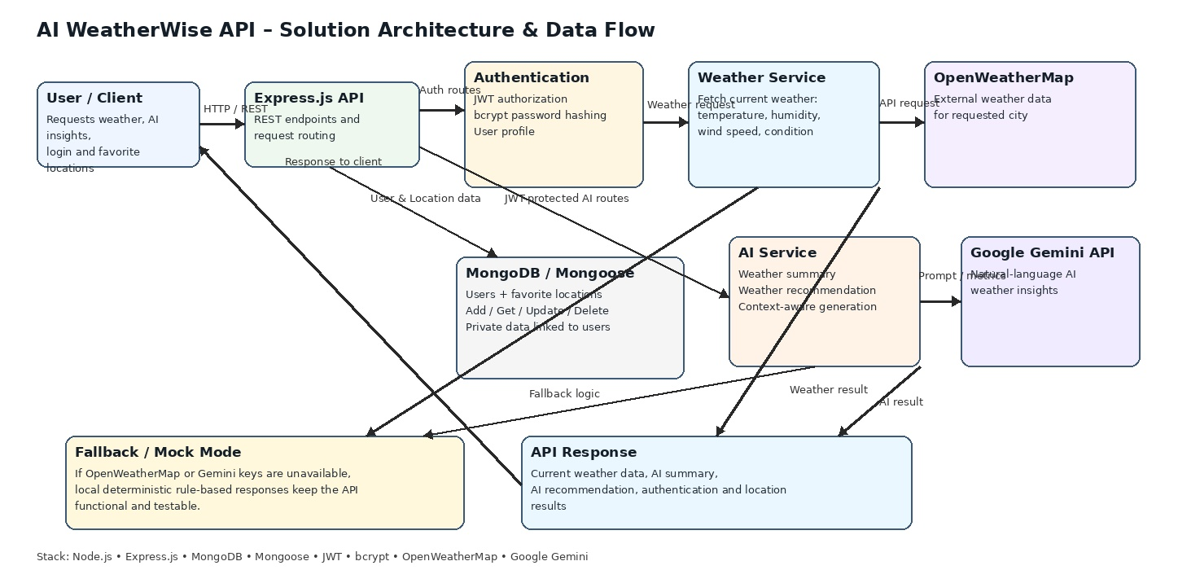
Figure 1: Architecture and data flow of the AI WeatherWise API
Project Reference: AI WeatherWise API project architecture and implemented API services

